**Rooftop Track & Pedestal System Installation Guidelines**

**Tools Needed for this Installation:**  **Material Provided by Mbrico:**

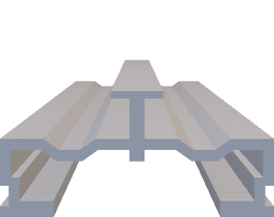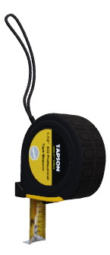

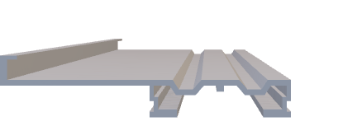

Offset L-Track

T-Track

Mbrico Tile

(Sizes Vary by Project)

Tape Measure

Laser Level

6’ Level

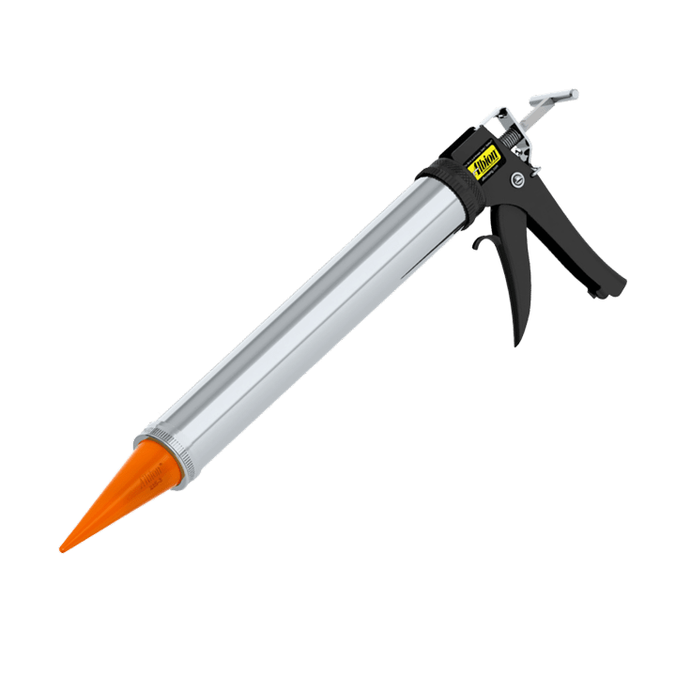

Rubber Mallet or Dead Blow Hammer

Pedestal

Pedestal Click Adapter

#8 x 1 1/4” Self Drilling Stainless Screws

Razor Knife

20oz Sausage Tube Dispenser

Drill w/ ¼” Aluminum Cutting Drill Bit

Router w/

½” collet

8” Sleeve Connector

Mbrico Field Slotter Router Bit

12’ Cross Brace Channel

Impact Driver w/ Phillips Drive Bits

Saw w/ Aluminum Blade

Wet Tile Saw or Angle Grinder w/ Correct Porcelain Blade

20oz Adhesive Tube

**Mbrico Rooftop Track & Pedestal Installation Video Mbrico Rooftop Track & Pedestal Details**

**Mbrico Rooftop Track & Pedestal System Installation Guidelines**

The shop drawings provided by Mbrico are based on the plans or dimensions supplied by the customer. Make sure to verify all measurements on-site before starting the installation.

**Preparation**

Before you begin, carefully read the written instructions and watch Mbrico’s relevant instructions videos in full.

The information below provides the recommended installation steps for the Mbrico Tile Track and Pedestal system. These guidelines help ensure a successful installation. However, it is up to the buyer and the on-site installer to make sure the installation is done correctly and follows Mbrico’s guidelines.

**Professional Help**

Mbrico advises clients to consult a qualified carpentry crew, roofing company, or tile setter in their area before placing and order. This ensures that all measurements, order quantities, and the installation are accurate. For larger projects, consider contacting Mbrico for a turn-key installation quote.

**Layout and Installation**

If possible, follow the layout used when ordering your Mbrico roof-top deck surface materials. This will help minimize cuts and place partial tiles in less visible areas of the space. In many ways, installing your Mbrico roof-top deck is like laying interior tile, requiring planning for stairways, angles, and partial rows. You will also need to plan for handrail installation and the size of the finished edge material. Install your Mbrico roof-top deck with care, as it will last longer than other deck products and requires only an occasional spray cleaning.

**System Height and Weight**

The Mbrico deck surface adds 2-5/8” to the roof or substructure height and a total weight of 10.5 pounds per square foot. Contact your salesperson for lower clearance alternatives.

**Easy Installation**

Mbrico has taken great care to create a pedestal system that is easy to install. The installation process is like that of a tongue-and-groove wood floor. This product was designed for a quality carpentry or roofing crew to install and offers clients years of maintenance-free enjoyment saving on refinishing and replacement cost that other deck surfaces require. Mbrico’s roof-top pedestal is ideal for clients who are not satisfied with conventional plastic, concrete pavers or wood decking options. The textures and finishes offered by Mbrico suit any quality home, building or project.

**Design Goals**

The Mbrico Rooftop Track & Pedestal system was designed with two main goals:

1. To provide clients with the best possible rooftop pedestal system that requires no maintenance and increases the long-term value of their home.
2. To create a complete rooftop pedestal system that is simple in both design and installation, making the installer’s job easier.

**Mbrico has achieved these goals by incorporating the following features to benefit both the installer and the client:**

* **12-Foot Aluminum Tracks:** These tracks are purposely made as long as possible to provide a straight edge for placing tiles across the deck surface, allowing for a quick and efficient installation.
* **Integrated Tile Spacer:** A 1/8” tile spacer is designed into the track, and 1/16” end bumpers

are built into each tile, creating a consistent 1/8” margin around all four sides of each tile.

* **Grout-Free Construction:** No tile setter is required.
* **Field Slotter Router Bits:** These bits are available for your router to quickly re-groove field-cut tiles to fit the track for cut rows or angled pieces.
* **Simple Stair System:** An optional, ready-to-install stair system for deck stringers is available.
* **Track Design:** The pre-applied tile substrate eliminates the need for thinset, mortar, or grout anywhere within the system, preventing wind uplift and any tile lippage or wobble.
* **Wind Uplift Protection:** The Mbrico Rooftop Track & Pedestal system has been tested at 160 MPH wind loads, equivalent to a Category 5 hurricane. Mbrico is Florida Product Approved with Miami-Dade Notice of Acceptance (NOA). Contact your Mbrico salesperson for wind uplift specifics and documentation. See optional Step 27 if project requires to meet Miami-Date NOA.

**Mbrico’s Patented Rooftop Pedestal System Layered Detail**

**Tile Rooftop Pedestal System Installation Steps**

Step 1: Verify roof is waterproof and clean for installation.

Step 2: Verify height clearance is at least 2-5/8” or higher (contact salesperson for lower clearance alternatives)

Step 3: Verify slope of roof deck and all adjoining floors & doorways to ensure correct pedestals were ordered to reach desired finish floor height. Refer to provided Mbrico project shop drawings for pedestal key and color-coded pedestal layout map.

Step 4: Place first row of pedestals, per provided project layout, at your designated starting edge. Refer to provided Mbrico shop drawing suggested control/starting point for your project. Place pedestals 30” on center.

Step 5: Adjust pedestal height to meet desired finish floor height (remember to account for the 1-5/8” rack and tile thickness).

Step 6: Place your Mbrico Offset L-Track into click-adapter on top of pedestal. Press down until track “clicks” into pedestal click adapter.

Step 7: To join two pieces of tracks together, attach an 8” aluminum sleeve connector with provided stainless screws. Pre-drill and place one screw on each side of 8” sleeve connector. The sleeve connector is used to connect two pieces of 12’ tracks end to end as needed. Note: a pedestal needs to be place at this connection.

Step 8: Place the next row of pedestals per your layout at designated location. Offset row of pedestals 50% from previous row so each row of pedestals are staggered. This eliminates any possible deflection in the system.

Step 9: Adjust pedestal height to reach desired finish floor elevation. Each pedestal is threaded for adjustment up or down.

Step 10: Place Mbrico T-Track into click-adapters and press down to “click” tracks into the top of each pedestal. Refer to Step 7 for sleeve connectors attachment as needed.

Step 11: Slide your Mbrico T-Track and row of pedestals into position. The gap between the 2 prepared tracks should be ½” wider that the width of your ordered tile. For example, if using 24x24” tile, the tracks will be 24.5” apart for this step until fully secured.

Verify the 2 rows of tracks are level prior to installing tiles. Make any final adjustments to pedestals as needed.

Step 12: Using a 1/8” drill bit, pre-drill track and crossbrace before attaching with provided stainless screws. Repeat attaching crossbrace under the track every 6 foot on center. One stainless screw will be used at each intersection of 12’ track and 12’ cross brace channel. Cross brace channels are installed under the tracks running perpendicular and maintain perfect spacing and gaps in tiles over time.

Step 13: Place a dab of the provided noise dampening adhesive onto the tracks where all four corners of the tile will sit on each track. The adhesive dab should be approximately the size of a quarter.

Step 14: Place a row of Mbrico tiles at the designated location in between both rows of track and pedestals.

Step 15: Using a rubber mallet or dead blow hammer, slide the Mbrico tile, track, and pedestals towards your previous track until all tile grooves are fully seated in the track and your two tracks are snug and parallel. Verifying each tile is snug and tongue and groove is fully engaged allows you to easily maintain perfect spacing as you continue.

Step 16: Verify with a laser or level that all tiles are sitting level and free from movement before moving to next row.

Step 17: Attach 12’ crossbrace channel to T-Track. There will be only one screw per intersection of track and crossbrace. Remember to pre-drill track and crossbrace for easier fastening.

Step 18: Repeat steps 8 through 17 until you reach the final row of tile.

Step 19: Place final row of pedestals in position and verify all heights and level. Allow for 1 5/8” track and tile thickness for appropriate final system finish floor elevation.

Step 20: At final row of tile, cut final offset L-Track ½” shorter than the length of 2-3 tiles and place track on top of final row of pedestals. Press down until the track “clicks” into place in the pedestal click adapters.

Step 21: Using 1 provided screw, pre-drill and attach your final row of tracks to cross brace channel underneath the track.

Step 22: Place dabs of provided Mbrico adhesive onto the track where all four corners of tiles will sit on tracks.

Step 23: Slide tile from track end into designated location. Repeat previous 3 steps to complete this segment of tracks.

Step 24: Repeat steps 20-23 until you reach the final tile.

Step 25: Cut the bottom lip of the last tile with a porcelain blade. Remove the bottom lip of a grooved edge of a tile.

Step 26: After applying 4 adhesive dabs on the tracks, slide the final tiles grooved edge into your T-Track and gently place down cut edge onto offset L-Track.

Step 27: For projects with wind uplift requirements, install optional ledger/base around entire Mbrico system perimeter. Ledger/base supplied by others. Materials example: Aluminum, Composite, Masonry. Contact your Mbrico salesperson for details.

**Congratulations! You are done with your Mbrico Rooftop Track & Pedestal system! See Mbrico’s Instructional video library for more on cutting, stairs, trims, and more.**